***Website: www.gpm.ac.in***

***E-mail:gpm1985105@gmail.com***

***Ph: 9734962796***



**GOBINDA PRASAD MAHAVIDYALAYA**

(NAAC Accredited ‘B+’ College)

AMARKANAN :: BANKURA, 722133 (W.B.)

Ref. No… Dated : ....................

**USE OF ICT TOOLS : 2021-2022**

1. TOTAL NO OF DESKTOP : **75**
2. TOTAL NO OF LAPTOP: **07**
3. TOTAL NO OF PRINTER : **15**
4. TOTAL NO OF PROJECTER : **03**
5. TOTAL NO OF SOUND SYSTEM : **02**
6. TOTAL NO OF XEROX : **02**
7. TOTAL NO OF SCANNER : **06**
8. TOTAL NO OF HEAD PHONE : **09**
9. TOTAL NO OF CC TV : **25**

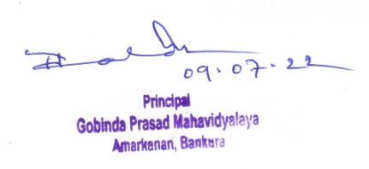

**Dr. Tushar Kanti Halder**

**Principal**

**Gobinda Prasad Mahavidyala**