GOBINDA PRASAD MAHAVIDYALAYA
SESSION: 2021-2022 DEPARTMENT OF BENGALI
ANALYSIS OF ONLINE STUDENT FEEDBACK ON THE EXISTING CURRICULUM

- % Of online feedback taken from 25 students

SL NO | Statements | Totally agree | Sometime agree | Can’t say | Totally disagree
1. | The curriculum helped us to gain knowledge | 66.7 | 20.8 | 0 | 12.5
2. | The curriculum helped us to prepare for job market | 48 | 32 | 8 | 12
3. | Teachings involve subjective, practical and fieldwork other than only lecture | 60 | 32 | 0 | 8
4. | Class environment was conductive in learning | 64 | 20 | 4 | 12
5. | Use of audio-visual aid was necessary | 56.5 | 26.1 | 8.7 | 8.7
6. | Students’ seminar/ student quiz in the class was necessary | 56 | 16 | 12 | 16
7. | Learning materials (class notes) were useful | 64 | 20 | 0 | 16
8. | Learning resources (books etc) in the library are adequate and necessary | 60 | 20 | 8 | 12
9. | Class teaching arose my interest in studies | 64 | 16 | 8 | 12
10. | Ideas and concepts were presented clearly in class | 64 | 16 | 8 | 12

- Student’s feedback on introduction of new subjects in the curriculum
- % Of online feedback taken from 25 students

Sl No. | Statements | Yes | No
1. | The college should introduce more new subjects (offered by the University) | 96.2 | 3.8
2. | The college should introduce more career-oriented programmes | 96.2 | 3.8
3. | Which new subject from university curriculum the college should introduce | 84.6 | 15.4

Analysis of the statement’s of Students

S1: Here 66.7 % students totally agree responses with the statement, 20.8 % sometime agree responses with the statement, 0% can’t say responses with the statement and 12.5 % totally disagree with the statement.
So, it is the clear from the responses of the student that a majority of the student think that the curriculum helped them to gain knowledge.
S2: Here 48 % students totally agree responses with the statement, 32 % sometime agree responses with the statement, 8 % can’t say responses with the statement and 12 % totally disagree with the statement.
So, it is the clear from the responses of the students that many students think that the curriculum helped them to prepare for the job market.
S3: Here 60 % students totally agree responses with the statement, 32 % sometime agree responses with the statement, 0% can’t say responses with the statement and 8% totally disagree with the statement.
So, it is the clear from the responses of the students that many students think that teachings involve subjective, practical and fieldwork other than only lecture.
S4: Here 64 % students totally agree responses with the statement, 20 % sometime agree responses with the statement, 4 % can’t say responses with the statement and 12 % totally disagree with the statement.
So, it is the clear from the responses of the students that many students think that class environment was conductive in learning.
S5 Here 56.5 % students totally agree responses with the statement, 26.1 % sometime agree responses with the statement, 8.7 % can’t say responses with the statement and 8.7 % totally disagree with the statement.
So, it is the clear from the responses of students that a majority of the students think that use of audio-visual aid was necessary.
S6: Here 56 % students totally agree responses with the statement, 16 % sometime agree responses with the statement, 12 % can’t say responses with the statement and 16 % totally disagree with the statement.
So, it is the clear from the responses of the students that many students think that
students’ seminar/ students quiz in the class was necessary.

S7: Here 64 % students totally agree responses with the statement, 20 % sometime agree responses with the statement, 0% can’t say responses with the statement and 16 % totally disagree with the statement.
So, it is the clear from the responses of the students that a majority of the students think that learning materials (class notes) were useful.
S8: Here 60 % students totally agree responses with the statement, 20 % sometime agree responses with the statement, 8 % can’t say responses with the statement and 12 % totally disagree with the statement.
So, it is the clear from the responses of the students that a majority of the student think that learning resources (books etc.) in the library are adequate and necessary.
S9: Here 64 % students totally agree responses with the statement, 16 % sometime agree responses with the statement, 8 % can’t say responses with the statement and 12 % totally disagree with the statement.
So, it is the clear from the responses of the students that many students think that Class teaching arose my interest in studies.
S10: Here 64 % students totally agree responses with the statement, 16 % sometime agree responses with the statement, 8 % can’t say responses with the statement and 12 % totally disagree with the statement.
So, it is the clear from the responses of the student that a majority of the student think that Ideas and concepts were presented clearly in class.

Student’s feedback on introduction of new subjects in the curriculum Analysis of the statements of Students
S1: Here 96.2 % students yes responses with the statement, 3.8 % no responses with the statement.

So, it is the clear from the responses of the student that a majority of the student think that the college should introduce more new subjects (offered by the University).
S2: Here 96.2 % students yes responses with the statement, 3.8 % no responses with the statement.

So, it is the clear from the responses of the student that a majority of the student think that the college should introduce more career-oriented programmes.

S3: Here 84.6 % students yes responses with the statement,15.4 % no responses with the statement. So, it is the clear from the responses of the student that a majority of the student think that
Which new subject from university curriculum the college should introduce.

GOBINDA PRASAD MAHAVIDYALAYA

SESSION: 2021-2022 DEPARTMENT OF ENGLISH
ANALYSIS OF ONLINE STUDENT FEEDBACK ON THE EXISTING CURRICULUM

- % of online feedback taken from 35 students
SL  NO | Statements | Excellent | Very Good | Good | Average | Poor
1. | The syllabus was challenging. | 28.6 | 48.6 | 22.9 | 0 | 0
2. | The allocation of the credits to the course is appropriate in relation to the  level of course work. | 25.7 | 45.7 | 25.7 | 2.9 | 0
3. | The depth of the course content is adequate in relation to the expected Course Outcomes. | 17.1 | 42.9 | 31.4 | 8.6 | 0
4. | Almost entire syllabus was covered in  the class by the teacher. | 34.3 | 28.6 | 22.9 | 11.4 | 2.9
5. | The units/sections in the syllabus are  properly sequenced. | 20 | 45.7 | 22.9 | 8.6 | 2.9
6. | Whether syllabus is carrier oriented? | 28.6 | 40 | 22.9 | 5.6 | 2.9
7. | The syllabus enabled me to improve my ability to formulate, analyze and solve  problems. | 40 | 28.6 | 20 | 11.4 | 0
8. | Syllabus inculcated necessary ethical  values and concern for the society. | 37.1 | 37.1 | 20 | 2.9 | 2.9
9. | The recommended textbooks are adequately available and map onto the  syllabus. | 20 | 45.7 | 22.9 | 8.6 | 2.9
10. | How do you rate the internal evaluation system as it exists regarding syllabus  is? | 31.4 | 37.1 | 28.6 | 2.9 | 0

Online Student’s Feedback on the Existing Curriculum
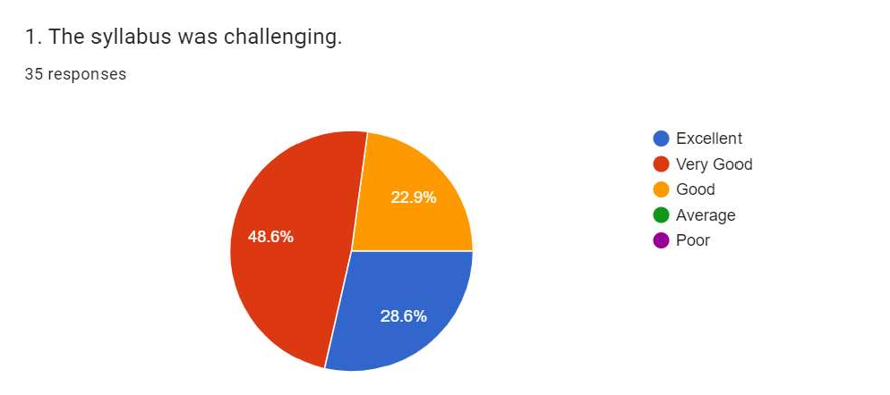

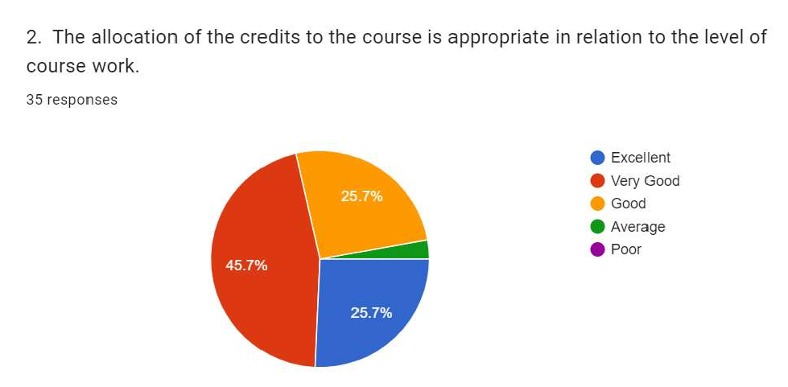

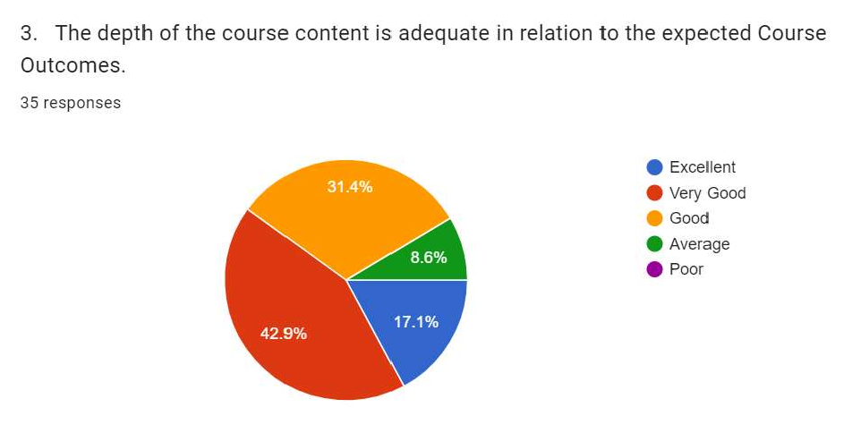

Almost entire syllabus was covered in the class by the teacher.
3 5 res t›onses

” @ Excellent
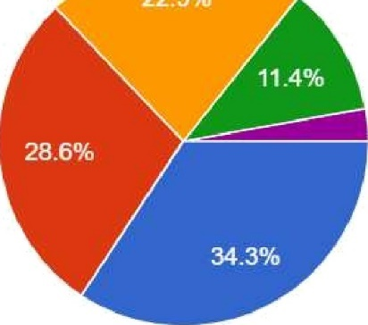
@ Very Good Good
@ Average @ Poor

The units/sections in the syllabus are properly sequenced.
35 responses

“' -“ @ Excellent
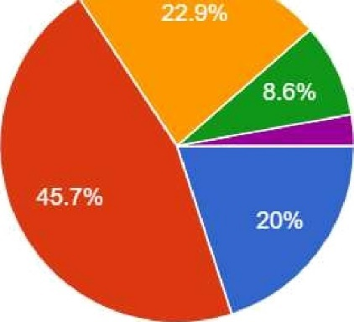
@ Very Good
/¿ Good @ Average @ Poor

Whether syllabus is carrier oriented?
35 responses

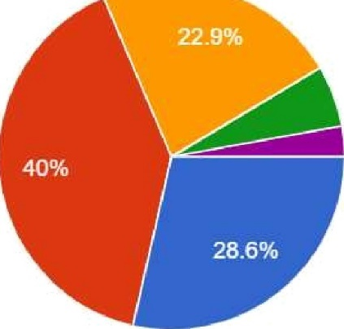
@ Excellent
@ Very Good
:... Good @ Average @ Poor

  - The syllabus enabled me to improve my ability to formulate, analyze and solve problems.
3 5 responses

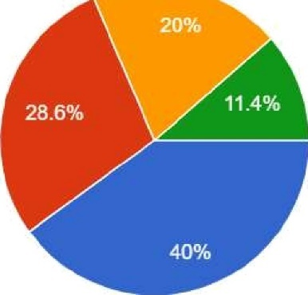
@ Excellent @ Very Good
Good @ Average

Syllabus inculcated necessary ethical values and concern for the society.
35 responses

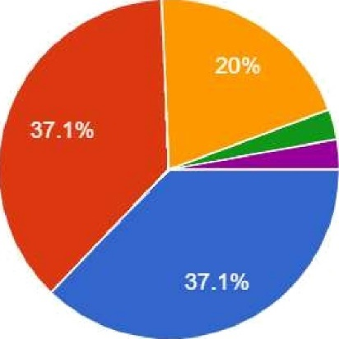
@ Excellent @ Very Good
*/ Good
@ Average @ Poor

  - The recommended textbooks are adequaleIy available and map onto the syllabus.
3 5 responses

- ” -” @ Excellent
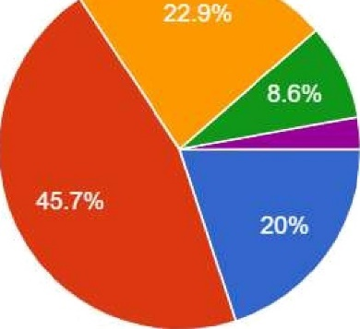
@ Very Good
} Good @ Average

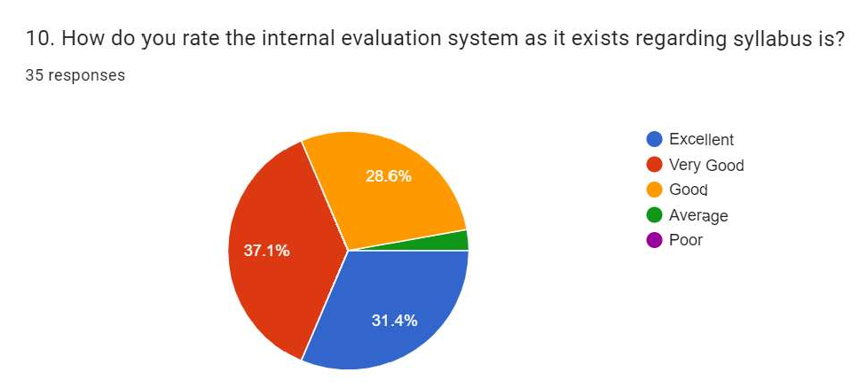

Analysis of the statement’s of Students
S1: Here 28.6% students excellent responses with the statement, 48.6% very good responses with the statement, 22.9% good responses with the statement, 0% average responses with the statement and 0% poor with the statement.
So, it is the clear from the responses of the student that a majority of the student think that the syllabus was very good.
S2: Here 25.7% students excellent responses with the statement, 45.7% very good responses with the statement, 25.7% good responses with the statement, 2.9% average responses with the statement and 0% poor with the statement.
So, it is the clear from the responses of the students that many students think that the allocation of the credits to the course is appropriate in relation to the level of course work.
S3: Here 17.1% students excellent responses with the statement, 42.9% very good responses with the statement, 31.4% good responses with the statement, 8.6% average responses with the statement and 0% poor with the statement.
So, it is the clear from the responses of the students that many students think that the depth of the course content is adequate in relation to the expected Course Outcomes.
S4: Here 34.3% students excellent responses with the statement, 28.6% very good responses with the statement, 22.9% good responses with the statement, 11.4% average responses with the statement and 2.9% poor with the statement.
So, it is the clear from the responses of the students that many students think that syllabus was covered in the class by the teacher.
S5 Here 20% students excellent responses with the statement, 45.7% very good responses with the statement, 22.9% good responses with the statement, 8.6% average responses with the statement and 2.9% poor with the statement.

So, it is the clear from the responses of students that a majority of the students think that the units/sections in the syllabus are properly sequenced.
S6: Here 28.6% students excellent responses with the statement, 40% very good responses with the statement, 22.9% good responses with the statement, 5.6% average responses with the statement and 2.9% poor with the statement.
So, it is the clear from the responses of the students that many students think that syllabus is carrier oriented.
S7: Here 40% students excellent responses with the statement, 28.6% very good responses with the statement, 20% good responses with the statement, 11.4% average responses with the statement and 0% poor with the statement.
So, it is the clear from the responses of the students that a majority of the students think that the syllabus enabled me to improve my ability to formulate, analyze and solve problems.
S8: Here 37.1% students excellent responses with the statement 37.1% very good responses with the statement, 20% good responses with the statement, 2.9% average responses with the statement and 2.9% poor with the statement.
So, it is the clear from the responses of the students that a majority of the student think that syllabus inculcated necessary ethical values and concern for the society.
S9: Here 20% students excellent responses with the statement, 45.7% very good responses with the statement, 22.9% good responses with the statement, 8.6% average responses with the statement and 2.9% poor with the statement.
So, it is the clear from the responses of the students that many students think that textbooks are adequately available and map onto the syllabus.
S10: Here 31.4% students excellent responses with the statement, 37.1% very good responses with the statement, 28.6% good responses with the statement, 2.9% average responses with the statement and 0% poor with the statement.
So, it is the clear from the responses of the student that a majority of the student think that the internal evaluation system as it exists regarding syllabus.

GOBINDA PRASAD MAHAVIDYALAYA
SESSION: 2021-2022 DEPARTMENT OF GEOGRAPHY
ANALYSIS OF ONLINE STUDENT FEEDBACK ON THE EXISTING CURRICULUM

- % of online feedback taken from 04 students

SL  N O | Statements |  |  | Totally agree | Someti me agree | Can’t say | Disag ree | Totally disagre e
1. | The curriculum helped gain knowledge | us | to | 50 | 25 | 0 | 0 | 25
2. | The curriculum helped prepare for job market | us | to | 25 | 50 | 0 | 0 | 25
3. | Teachings involve subjective, practical and fieldwork other than only lecture |  |  | 50 | 25 | 0 | 25 | 0
4. | Class environment conductive in learning |  | was | 75 | 0 | 0 | 25 | 0
5. | Use of audio visual aid was necessary |  |  | 50 | 25 | 25 | 0 | 0
6. | Students seminar/ student quiz in the class was necessary |  |  | 50 | 25 | 0 | 0 | 25
7. | Learning materials(class notes) were useful |  |  | 50 | 25 | 0 | 0 | 25
8. | Learning resources(books etc)in  the library are adequate and necessary |  |  | 50 | 50 | 0 | 0 | 0
9. | Class teaching arose my interest in studies |  |  | 50 | 50 | 0 | 0 | 0
10. | Ideas and concepts were presented clearly in class |  |  | 75 | 0 | 0 | 25 | 0

Online Student’s Feedback on the existing curriculum

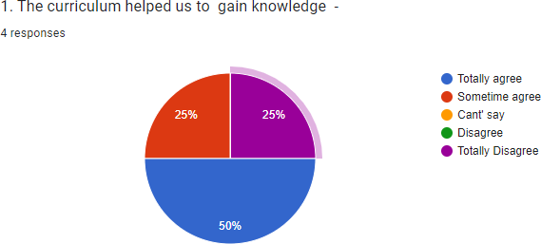

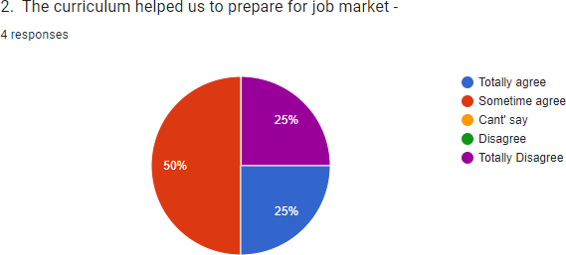

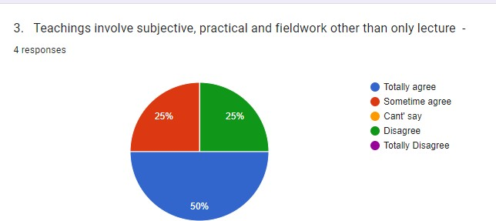

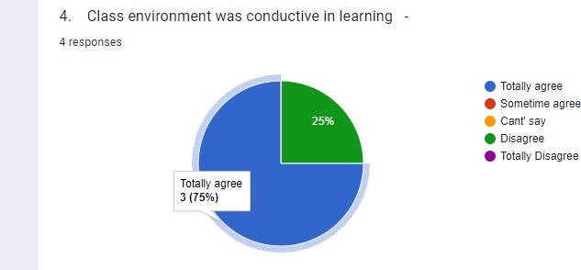
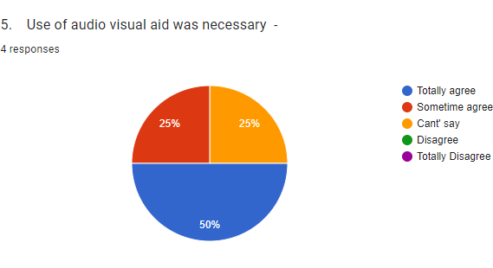

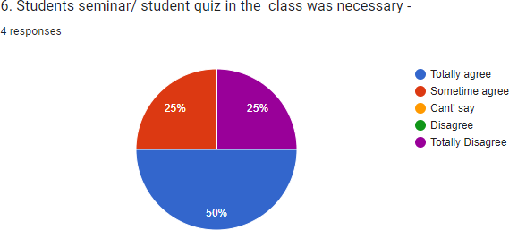

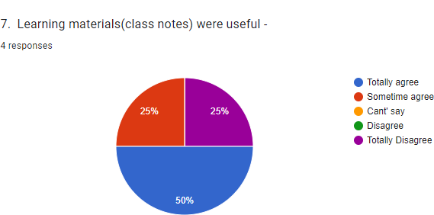

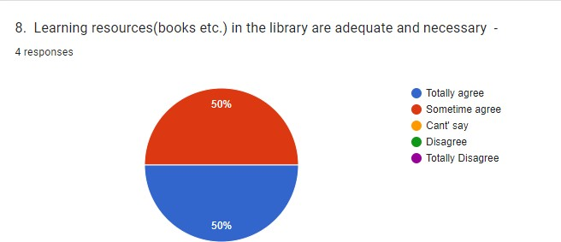

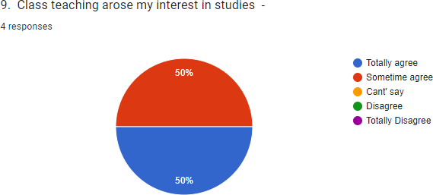

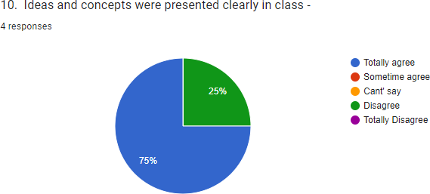

Analysis of the statement’s of Students

S1: Here 50% students totally agree responses with the statement, 25% sometime agree responses with the statement, 0% can’t say responses with the statement, 0% disagree responses with the statement and 25% totally disagree with the statement.
So, it is the clear from the responses of the student that a majority of the student think that the curriculum helped them to gain knowledge.
S2: Here 25% students totally agree responses with the statement, 50% sometime agree responses with the statement, 0% can’t say responses with the statement, 0% disagree responses with the statement and 25% totally disagree with the statement.
So, it is the clear from the responses of the students that many students think that the curriculum helped them to prepare for the job market.
S3: Here 50% students totally agree responses with the statement, 25% sometime agree responses with the statement, 0% can’t say responses with the statement, 25% disagree responses with the statement and 0% totally disagree with the statement.
So, it is the clear from the responses of the students that majority of the students think that teachings involve subjective, practical and fieldwork other than only lecture.
S4: Here 75% students totally agree responses with the statement, 0% sometime agree responses with the statement, 0% can’t say responses with the statement, 25% disagree responses with the statement and 0% totally disagree with the statement.
So, it is the clear from the responses of the students that majority of the students think that class environment was conductive in learning.

S5 Here 50% students totally agree responses with the statement, 25% sometime agree responses with the statement, 25% can’t say responses with the statement, 0% disagree responses with the statement and 0% totally disagree with the statement.
So, it is the clear from the responses of students that a majority of the students think that use of audio visual aid was necessary.
S6: Here 50% students totally agree responses with the statement, 25% sometime agree responses with the statement, 0% can’t say responses with the statement, 0% disagree responses with the statement and 25% totally disagree with the statement.
So, it is the clear from the responses of the students that majority of the students think that students seminar/ students quiz in the class was necessary.
S7: Here 50% students totally agree responses with the statement, 25% sometime agree responses with the statement, 0% can’t say responses with the statement, 0% disagree responses with the statement and 25% totally disagree with the statement.
So, it is the clear from the responses of the students that a majority of the students think that learning materials (class notes) were useful.
S8: Here 50% students totally agree responses with the statement, 50% sometime agree responses with the statement, 0% can’t say responses with the statement, 0% disagree responses with the statement and 0% totally disagree with the statement.
So, it is the clear from the responses of the students that a half of the student think that learning resources (books etc) in the library are adequate and necessary.
S9: Here 50% students totally agree responses with the statement, 50% sometime agree responses with the statement, 0% can’t say responses with the statement, 0% disagree responses with the statement and 0% totally disagree with the statement.
So, it is the clear from the responses of the students that half of the students think that Class teaching arose my interest in studies.
S10: Here 75% students totally agree responses with the statement, 0% sometime agree responses with the statement, 0% can’t say responses with the statement, 25% disagree responses with the statement and 0% totally disagree with the statement.
So, it is the clear from the responses of the student that a majority of the student think that Ideas and concepts were presented clearly in class.

GOBINDA PRASAD MAHAVIDYALAYA

SESSION: 2021-2022 DEPARTMENT OF HISTORY
ANALYSIS OF ONLINE STUDENT FEEDBACK ON THE EXISTING CURRICULUM

% Of online feedback taken from 25 students

SL NO | Statements | Totall y agree | Sometim e agree | Can’t say | Disag ree | Totally disagree
1. | The curriculum helped us to gain knowledge | 76 | 4 | 4 | 8 | 8
2. | The curriculum helped us to prepare for job market | 56 | 20 | 8 | 8 | 8
3. | Teachings involve subjective, practical and fieldwork other than only lecture | 72 | 8 | 8` | 8 | 4
4. | Class environment was conductive in learning | 56 | 24 | 0 | 8 | 12
5. | Use of audio-visual aid was necessary | 58.3 | 20.8 | 4.2 | 8.3 | 8.3
6. | Students’ seminar/ student quiz in the class was necessary | 68 | 12 | 8 | 4 | 8
7. | Learning materials (class notes) were useful | 60 | 20 | 0 | 16 | 4
8. | Learning resources (books etc) in the library are adequate and necessary | 72 | 4 | 8 | 4 | 12
9. | Class teaching arose my interest in studies | 64 | 16 | 8 | 8 | 4
10. | Ideas and concepts were presented clearly in class | 68 | 12 | 0 | 12 | 8

Analysis of the statement’s of Students

S1: Here 76 % students totally agree responses with the statement, 4 % sometime agree responses with the statement, 4% can’t say responses with the statement, 8% Disagree with the statement and 8 % totally disagree with the statement.
So, it is the clear from the responses of the student that a majority of the student think that the curriculum helped them to gain knowledge.
S2: Here 56 % students totally agree responses with the statement, 20 % sometime agree responses with the statement, 8 % can’t say responses with the statement, 8% Disagree with the statement and 8 % totally disagree with the statement.
So, it is the clear from the responses of the students that many students think that the curriculum helped them to prepare for the job market.
S3: Here 72 % students totally agree responses with the statement, 8 % sometime agree responses with the statement, 8% can’t say responses with the statement, 8% Disagree with the statement and 4% totally disagree with the statement.
So, it is the clear from the responses of the students that many students think that teachings involve subjective, practical and fieldwork other than only lecture.
S4: Here 56 % students totally agree responses with the statement, 24 % sometime agree responses with the statement, 8% Disagree with the statement and 12 % totally disagree with the statement.
So, it is the clear from the responses of the students that many students think that class environment was conductive in learning.
S5 Here 58.3 % students totally agree responses with the statement, 20.8 % sometime agree responses with the statement, 4.2 % can’t say responses with the statement, 8.3% Disagree with the statement and 8.3 % totally disagree with the statement.
So, it is the clear from the responses of students that a majority of the students think that use of audio-visual aid was necessary.
S6: Here 68 % students totally agree responses with the statement, 12 % sometime agree responses with the statement, 8 % can’t say responses with the statement, 4% Disagree with the statement and 8 % totally disagree with the statement.
So, it is the clear from the responses of the students that many students think that
students’ seminar/ students quiz in the class was necessary.

S7: Here 60 % students totally agree responses with the statement, 20 % sometime agree responses with the statement, 16% Disagree with the statement and 4 % totally disagree with the statement.
So, it is the clear from the responses of the students that a majority of the students think that learning materials (class notes) were useful.
S8: Here 72 % students totally agree responses with the statement, 4 % sometime agree responses with the statement, 8 % can’t say responses with the statement, 4% Disagree with the statement and 12 % totally disagree with the statement.
So, it is the clear from the responses of the students that a majority of the student think that learning resources (books etc.) in the library are adequate and necessary.
S9: Here 64 % students totally agree responses with the statement, 16 % sometime agree responses with the statement, 8 % can’t say responses with the statement, 8% Disagree with the statement and 4 % totally disagree with the statement.
So, it is the clear from the responses of the students that many students think that Class teaching arose my interest in studies.
S10: Here 68 % students totally agree responses with the statement, 12 % sometime agree responses with the statement, 12 % can’t say responses with the statement and 8 % totally disagree with the statement.
So, it is the clear from the responses of the student that a majority of the student think that Ideas and concepts were presented clearly in class.

GOBINDA PRASAD MAHAVIDYALAYA
SESSION: 2021-2022
DEPARTMENT OF SANSKRIT
ANALYSIS OF ONLINE STUDENT FEEDBACK ON THE EXISTING CURRICULUM
- % of online feedback taken from 29 students
SL  NO | Statements | Excellent | Very Good | Good | Average | Poor
1. | The Syllabus Was challenging | 72.4 | 13.8 | 10.3 | 3.4 | 0
2. | The allocation of the credits to the course is appropriate in relation to the level of course work. | 72.4 | 3.4 | 20.7 | 3.4
3. | The depth of the course content is adequate in relation to the expected Course Outcome | 69 | 10.3 | 17.2 | 3.4 | 0
4. | Almost entire syllabus was covered in the class by the teacher. | 72.4 | 20.7 | 3.4 | 3.4 | 0
5. | The units/sections in the syllabus are properly sequenced | 72.4 | 10.3 | 13.8 | 3.4 | 0
6. | Whether syllabus is carrier oriented? | 64.3 | 17.9 | 14.3 | 3.6 | 0
7. | The syllabus enabled me to improve my ability to formulate, analyse and solve problems. | 65.5 | 20.7 | 13.8 | 0 | 0
8. | Syllabus inculcated necessary ethical values and concern for the society. | 72.4 | 13.8 | 13.8 | 0 | 0
9. | The recommended textbooks are adequately available and map onto the syllabus. | 69 | 10.3 | 17.2 | 3.4 | 0
10. | How do you rate the internal evaluation system as it exists regarding syllabus is? | 72.4 | 13.8 | 13.8 | 0 | 0

Student’s feedback on introduction of new subjects in the curriculum

Compare of Students Feedback

Analysis of the statements of Students
S1: Here 72.4% students excellent responses with the statement, 13.8% very good responses with the statement, 10.3% good responses with the statement, 3.4% average responses with the statement and 0% poor responses with the statement.
So, it is the clear from the responses of the student that a majority of the student think that the curriculum helped them to gain knowledge.
S2: Here 72.4% students excellent responses with the statement, 3.4% very good responses with the statement, 20.7% good responses with the statement, 3.4% average responses with the statement and 0% poor responses with the statement.
So, it is the clear from the responses of the students that many students think that the curriculum helped them to prepare for the job market.
S3: Here 69% students excellent responses with the statement, 10.3% very good responses with the statement, 17.2% good responses with the statement, 3.4% average responses with the statement and 0% poor responses with the statement.

So, it is the clear from the responses of the students that many students think that teachings involve subjective, practical and fieldwork other than only lecture.
S4: Here 72.4% students excellent responses with the statement, 20.7% very good responses with the statement, 3.4% good responses with the statement, 3.4% average responses with the statement and 0% poor responses with the statement.
So, it is the clear from the responses of the students that many students think that class environment was conductive in learning.
S5 Here 72.4% students excellent responses with the statement, 10.3% very good responses with the statement, 13.8% good responses with the statement, 3.4% average responses with the statement and 0% poor responses with the statement.
So, it is the clear from the responses of students that a majority of the students think that use of audio visual aid was necessary.
S6: Here 64.3% students excellent responses with the statement, 17.9% very good responses with the statement, 14.3% good responses with the statement, 3.6% average responses with the statement and 0% poor responses with the statement.
So, it is the clear from the responses of the students that many students think that students seminar/ students quiz in the class was necessary.
S7: Here 65.5% students excellent responses with the statement, 20.7% very good responses with the statement, 13.8% good responses with the statement, 0% average responses with the statement and 0% poor responses with the statement.
So, it is the clear from the responses of the students that a majority of the students think that learning materials (class notes) were useful.
S8: Here 72.4% students excellent responses with the statement, 13.8% very good responses with the statement, 13.8% good responses with the statement, 0% average responses with the statement and 0% poor responses with the statement.
So, it is the clear from the responses of the students that a majority of the student think that learning resources (books etc.) in the library are adequate and necessary.
S9: Here 69% students excellent responses with the statement, 10.3% very good responses with the statement, 17.2% good responses with the statement, 3.4% average responses with the statement and 0% poor responses with the statement.
So, it is the clear from the responses of the students that many students think that Class teaching arose my interest in studies.

S10: Here 72.4% students excellent responses with the statement, 13.8% very good responses with the statement, 13.8% good responses with the statement, 0% average responses with the statement and 0% poor responses with the statement.

So, it is the clear from the responses of the student that a majority of the student think that Ideas and concepts were presented clearly in class.

GOBINDA PRASAD MAHAVIDYALAYA

SESSION: 2021-2022 DEPARTMENT OF PHILOSOPHY
ANALYSIS OF ONLINE STUDENT FEEDBACK ON THE EXISTING CURRICULUM

% of online feedback taken from 25 students
SL  NO | Statements | Excellent | Very Good | Good | Average | Poor
1. | The syllabus was challenging. | 60 | 32 | 8 | 0 | 0
2. | The allocation of the credits to the  course is appropriate in relation to the level of course work. | 40 | 40 | 20 | 0 | 0
3. | The depth of the course content is adequate in relation to the expected Course Outcomes. | 32 | 48 | 20 | 0 | 0
4. | Almost entire syllabus was covered in  the class by the teacher. | 60 | 28 | 12 | 0 | 0
5. | The units/sections in the syllabus are  properly sequenced. | 56 | 28 | 8 | 4 | 4
6. | Whether syllabus is carrier oriented? | 56 | 36 | 4 | 4 | 0
7. | The syllabus enabled me to improve my  ability to formulate, analyze and solve problems. | 40 | 44 | 12 | 4 | 0
8. | Syllabus inculcated necessary ethical  values and concern for the society. | 24 | 56 | 20 | 0 | 0
9. | The recommended textbooks are  adequately available and map onto the syllabus. | 32 | 48 | 12 | 8 | 0
10. | How do you rate the internal evaluation  system as it exists regarding syllabus is? | 56 | 36 | 8 | 0 | 0

Online Student’s Feedback on the Existing Curriculum
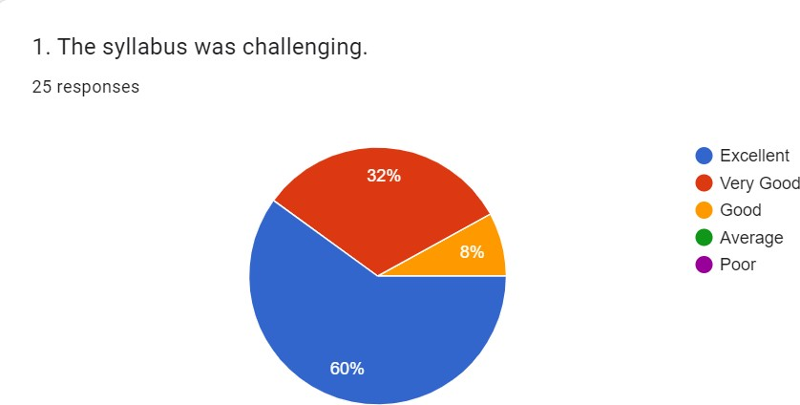

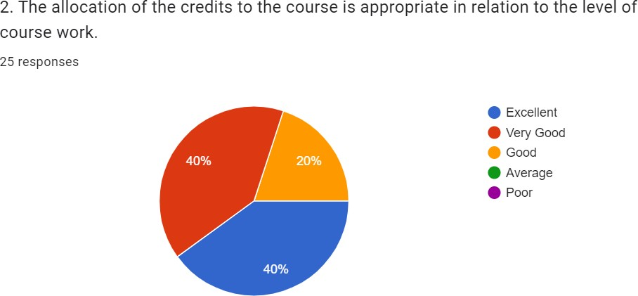

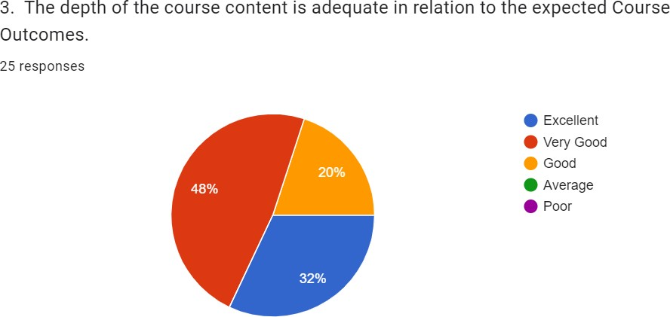

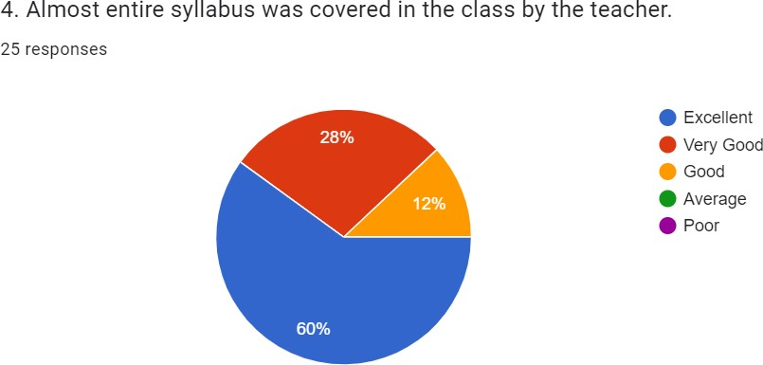

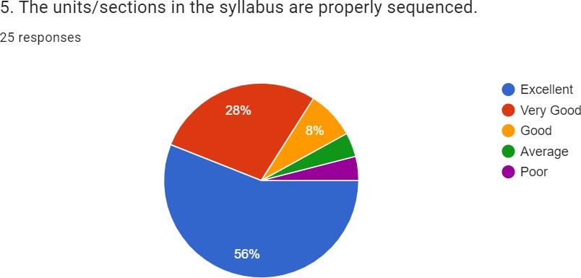

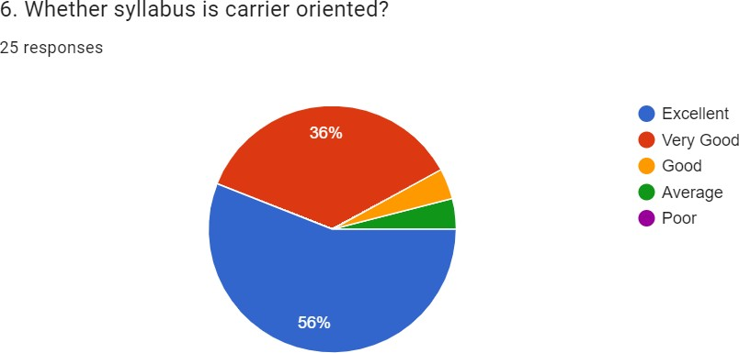

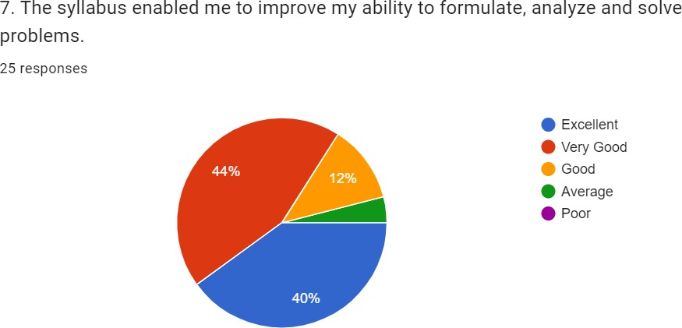

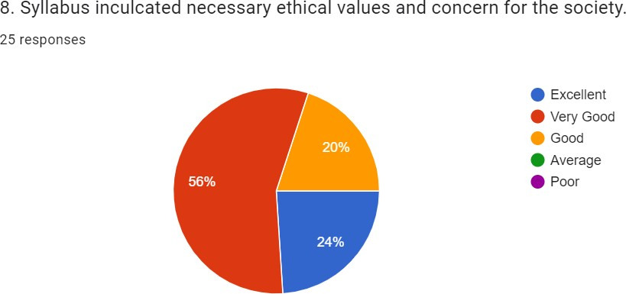

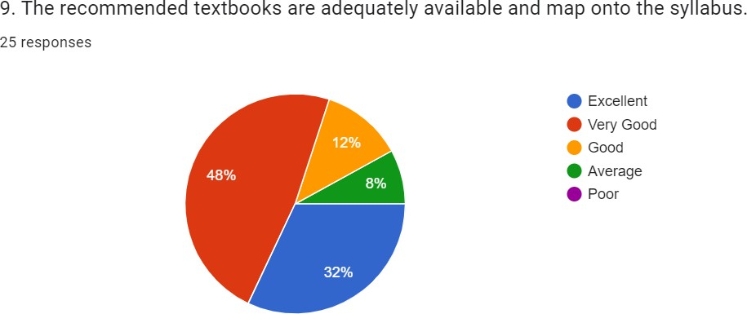

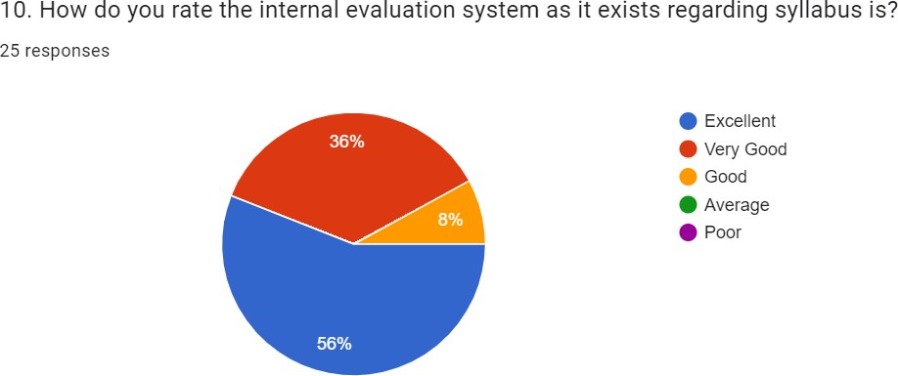

Analysis of the statement’s of Students
S1: Here 60% students excellent responses with the statement, 32% very good responses with the statement, 8% good responses with the statement, 0% average responses with the statement and 0% poor with the statement.
So, it is the clear from the responses of the student that a majority of the student think that the syllabus was very good.
S2: Here 40% students excellent responses with the statement, 40% very good responses with the statement, 20% good responses with the statement, 0% average responses with the statement and 0% poor with the statement.
So, it is the clear from the responses of the students that many students think that the allocation of the credits to the course is appropriate in relation to the level of course work.
S3: Here 32% students excellent responses with the statement, 48% very good responses with the statement, 20% good responses with the statement, 0% average responses with the statement and 0% poor with the statement.
So, it is the clear from the responses of the students that many students think that the depth of the course content is adequate in relation to the expected Course Outcomes.
S4: Here 60% students excellent responses with the statement, 28% very good responses with the statement, 12% good responses with the statement, 0% average responses with the statement and 0% poor with the statement.
So, it is the clear from the responses of the students that many students think that syllabus was covered in the class by the teacher.
S5 Here 56% students excellent responses with the statement, 28% very good responses with

the statement, 8% good responses with the statement, 4% average responses with the statement and 4% poor with the statement.
So, it is the clear from the responses of students that a majority of the students think that the units/sections in the syllabus are properly sequenced.
S6: Here 56% students excellent responses with the statement, 36% very good responses with the statement, 4% good responses with the statement, 4% average responses with the statement and 0% poor with the statement.
So, it is the clear from the responses of the students that many students think that syllabus is carrier oriented.
S7: Here 40% students excellent responses with the statement, 44% very good responses with the statement, 12% good responses with the statement, 4% average responses with the statement and 0% poor with the statement.
So, it is the clear from the responses of the students that a majority of the students think that the syllabus enabled me to improve my ability to formulate, analyze and solve problems.
S8: Here 24% students excellent responses with the statement 56% very good responses with the statement, 20% good responses with the statement, 0% average responses with the statement and 0% poor with the statement.
So, it is the clear from the responses of the students that a majority of the student think that syllabus inculcated necessary ethical values and concern for the society.
S9: Here 32% students excellent responses with the statement, 48% very good responses with the statement, 12% good responses with the statement,8% average responses with the statement and 0% poor with the statement.
So, it is the clear from the responses of the students that many students think that textbooks are adequately available and map onto the syllabus.
S10: Here 56% students excellent responses with the statement, 36% very good responses with the statement, 8% good responses with the statement, 0% average responses with the statement and 0% poor with the statement.
So, it is the clear from the responses of the student that a majority of the student think that the internal evaluation system as it exists regarding syllabus.

Department of Political Science

Gobinda Prasad Mahavidyalaya

Analysis of Feedback on Curriculum (2021 -2022)

 |  | Response of Students (in %)
Feedback on Course |  | Excellent / Excellently | Very Good | Good | Average | Poor
1 | The syllabus was challenging. | 33.3% | 46.7% | 20%
2 | The allocation of the credits to the course is appropriate in relation to the level of course  work | 73.3% | 26.7%
3 | The depth of the course content is adequate in relation to the expected Course Outcomes  (COs). | 40% | 33.3% | 26.7%
4 | Almost entire syllabus was covered in the class by the teacher. | 80% | 20%
5 | The units/sections in the syllabus are properly  sequenced. | 66.7% | 33.3%
6 | Whether syllabus is carrier oriented? | 80% | 20%
7 | The syllabus enabled me to improve my ability to formulate, analyze and solve problems. | 40% | 40% | 20%
8 | Syllabus inculcated necessary ethical values  and concern for the society. | 60% | 33.3% | 6.7%
9 | The recommended textbooks are adequately available and map onto the syllabus. | 53.3% | 46.7%
10 | How do you rate the internal evaluation system as it exists regarding syllabus is? | 26.7% | 46.7% | 26.7%

Excellently / Excellent – 1 Very good – 2

Good – 3

Average – 4

Poor – 5

After analyzing the feedback forms collected from students through online mode the major outcomes noticed here is that 33.33% of the students opined ‘excellent’ and 46.7% opined ‘very good’ on the issue that the syllabus was challenging; and 20% opined ‘good’ for the same question.

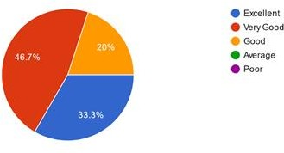

CHART 1

Students opinion is divided between ‘excellently’ (73.3%) and ‘very good’ (26.7%) on the question about the appropriateness of the allocation of the credits to the course in relation to the level of course work.

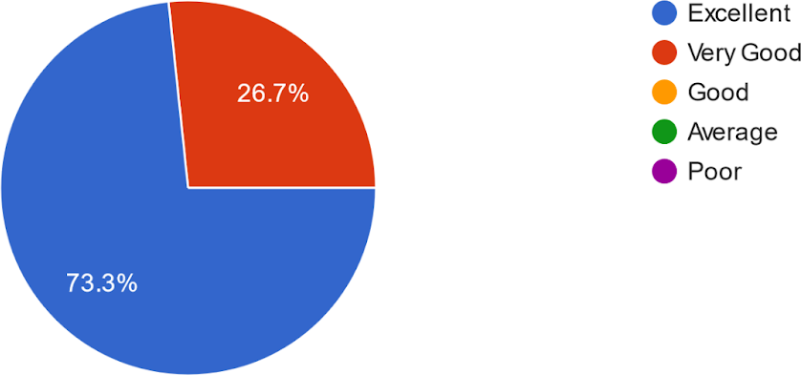

The adequacy of the depth of the course content in relation to the expected Course Outcomes is ‘excellent’ for 40%, for 33.3% it is ‘very good’ and for 26.7% it is good.

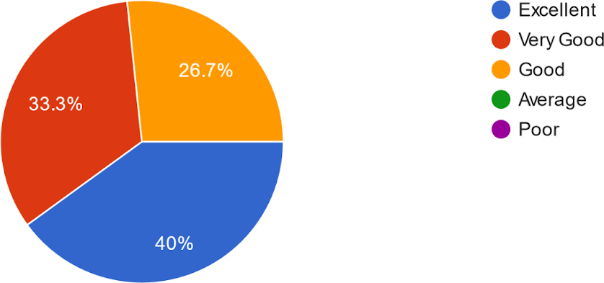

CHART 3

80% students viewed ‘excellent’ on the issue of covering the entire syllabus by the teacher in the class and 20% viewed it ‘very good’.

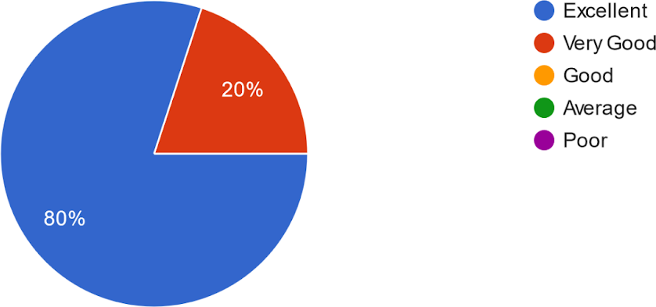

66.7% of students viewed ‘excellent’ in terms of proper sequencing of units/sections in the syllabus whereas 33.3% opined “very good’ for the same.

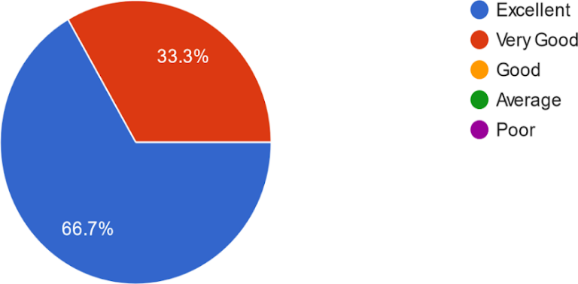

CHART 5

Students’ opinion is divided on the question that whether syllabus is carrier oriented. For 80 % it is ‘excellently’ and for 20% it is ‘very good’.

Again 40% students feel that the syllabus enabled them ‘excellently’ to improve their ability to formulate, analyze and solve problems; for 40% it is ‘very good’ and for 20% it is ‘good’ in doing so.

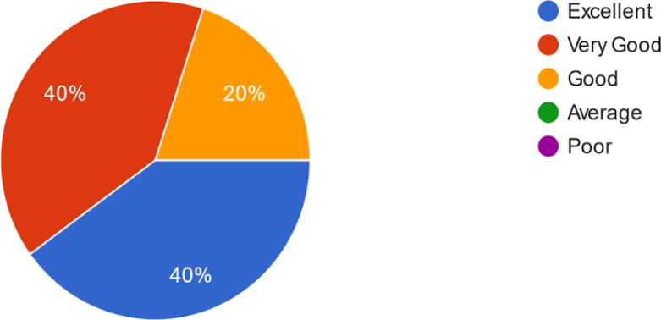

CHART 7

60% of students feel that the Syllabus is excellent in inculcating necessary ethical values and concern for the society among students, 33.3% feels ‘very good’ and 6.7% feels “good” for the same.

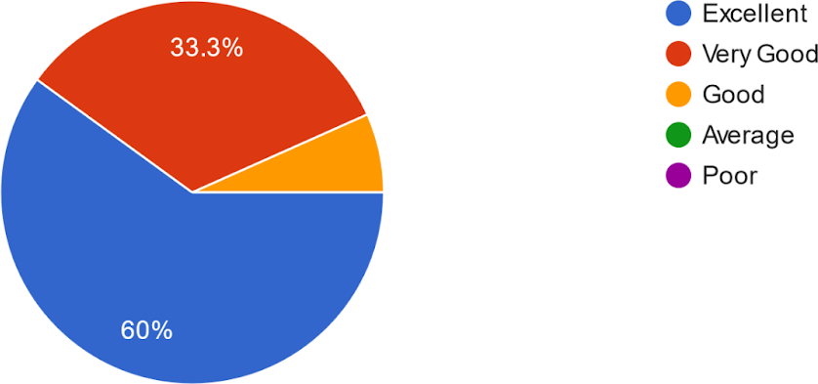

For the question “the recommended text books are adequately available and map on to the syllabus”, students’ opinions are like this, for 53.3% it is ‘excellent’ and for 46.7% it is ‘very good’.

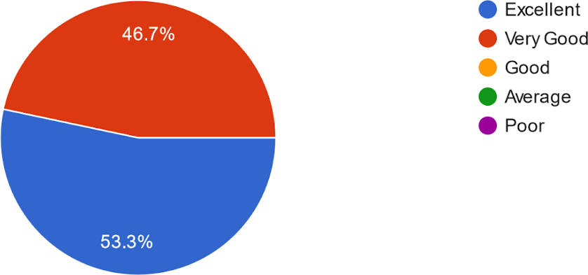

CHART 9

Regarding the internal evaluation system as it exists regarding syllabus, 26.7% rate it ‘excellent’ and ‘good’ each whereas for 46.7% it is ‘very good’.

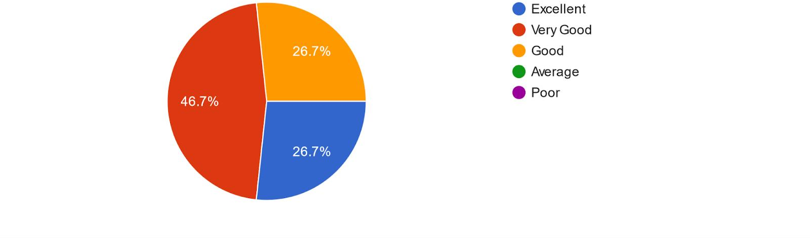

GOBINDA PRASAD MAHAVIDYALAYA

SESSION: 2021-2022 DEPARTMENT OF EDUCATION
ANALYSIS OF ONLINE STUDENT FEEDBACK ON THE EXISTING CURRICULUM

% of online feedback taken from 15 students
SL  NO | Statements | Excellent | Very Good | Good | Average | Poor
1. | The syllabus was challenging. | 33.33 | 53.33 | 13.33 | 0 | 0
2. | The allocation of the credits to the  course is appropriate in relation to the level of course work. | 26.67 | 46.67 | 26.67 | 0 | 0
3. | The depth of the course content is adequate in relation to the expected Course Outcomes. | 66.67 | 13.33 | 20 | 0 | 0
4. | Almost entire syllabus was covered in  the class by the teacher. | 46.67 | 26.67 | 26.67 | 0 | 0
5. | The units/sections in the syllabus are  properly sequenced. | 46.67 | 40 | 6.67 | 6.67 | 0
6. | Whether syllabus is carrier oriented? | 40 | 40 | 20 | 0 | 0
7. | The syllabus enabled me to improve my  ability to formulate, analyze and solve problems. | 40 | 46.67 | 13.33 | 0 | 0
8. | Syllabus inculcated necessary ethical  values and concern for the society. | 40 | 46.67 | 13.3 | 0 | 0
9. | The recommended textbooks are  adequately available and map onto the syllabus. | 40 | 40 | 20 | 0 | 0
10. | How do you rate the internal evaluation  system as it exists regarding syllabus is? | 73.33 | 13.33 | 13.33 | 0 | 0

Online Student’s Feedback on the Existing Curriculum

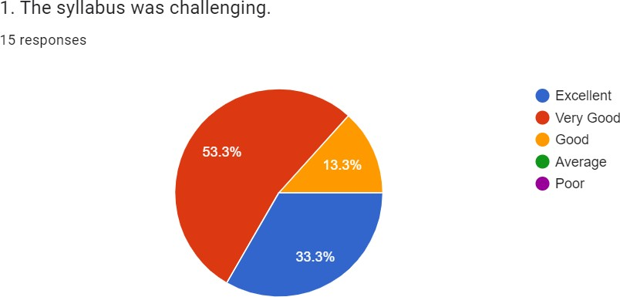

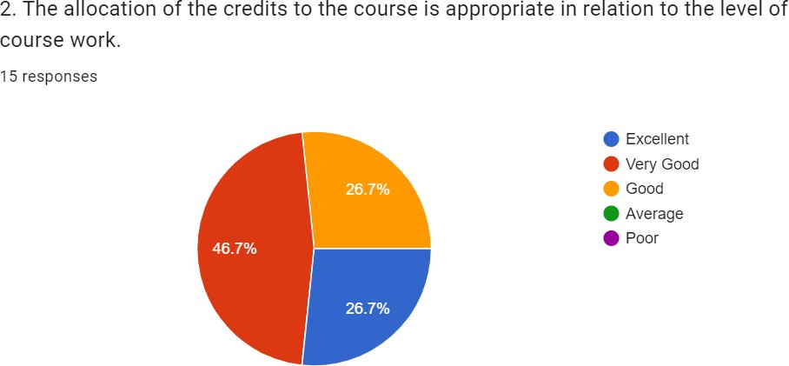

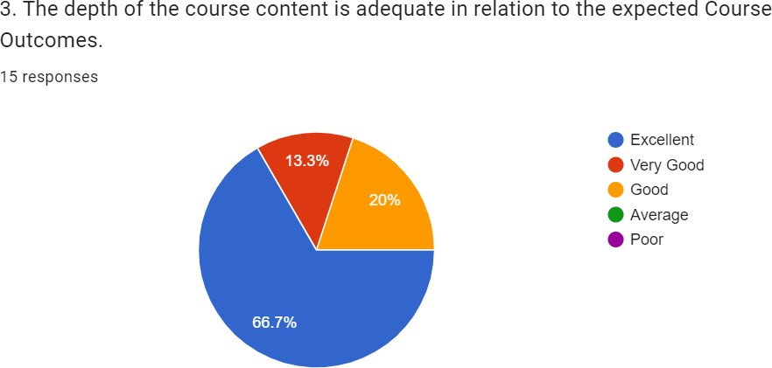

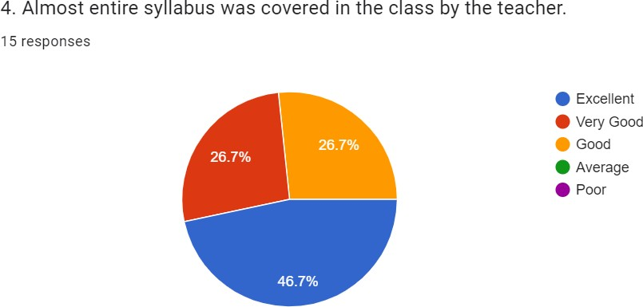

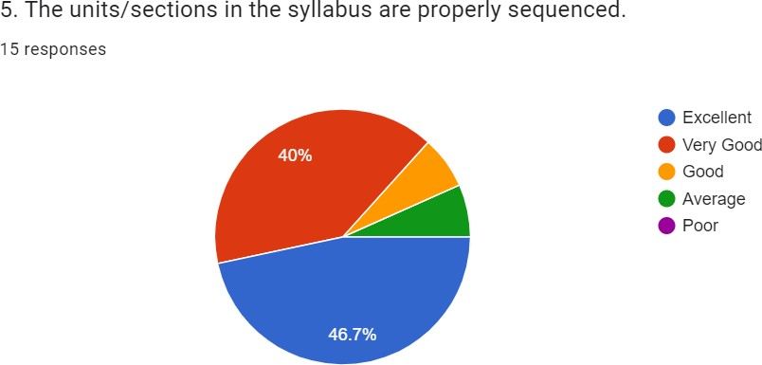

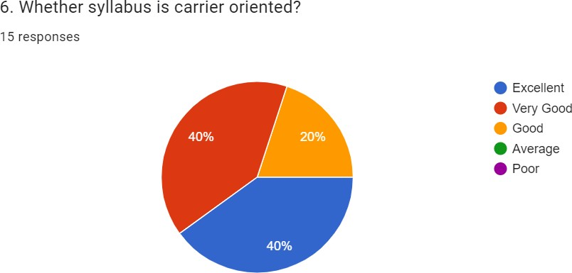

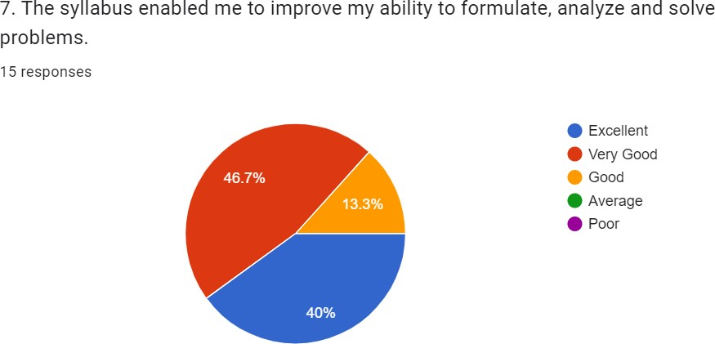

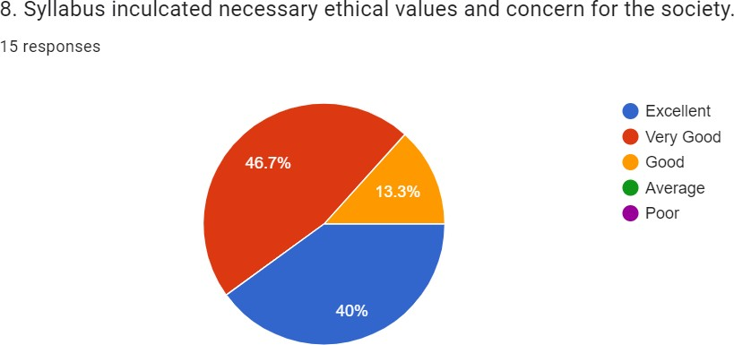

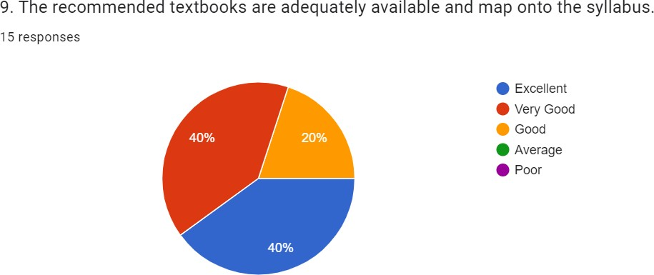

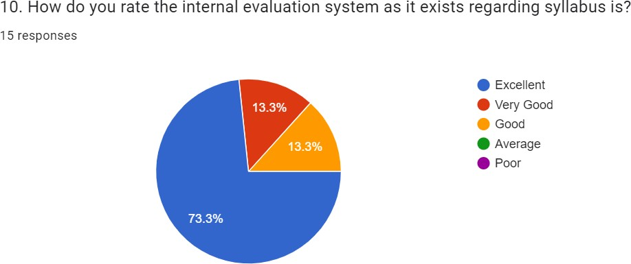

Analysis of the statement’s of Students

S1: Here 33.33% students excellent responses with the statement, 53.33% very good responses with the statement, 13.33% good responses with the statement, 0% average responses with the statement and 0% poor with the statement.
So, it is the clear from the responses of the student that a majority of the student think that the syllabus was very good.
S2: Here 26.67% students excellent responses with the statement, 46.67% very good responses with the statement, 26.67% good responses with the statement, 0% average responses with the statement and 0% poor with the statement.
So, it is the clear from the responses of the students that many students think that the allocation of the credits to the course is appropriate in relation to the level of course work.
S3: Here 66.67% students excellent responses with the statement, 13.33% very good responses with the statement, 20% good responses with the statement, 0% average responses with the statement and 0% poor with the statement.
So, it is the clear from the responses of the students that many students think that the depth of the course content is adequate in relation to the expected Course Outcomes.
S4: Here 46.67% students excellent responses with the statement, 26.67% very good responses with the statement, 26.67% good responses with the statement, 0% average responses with the statement and 0% poor with the statement.
So, it is the clear from the responses of the students that many students think that syllabus was covered in the class by the teacher.
S5 Here 46.67% students excellent responses with the statement, 40% very good responses with the statement, 6.67% good responses with the statement, 6.67% average responses with the statement and 0% poor with the statement.

So, it is the clear from the responses of students that a majority of the students think that the units/sections in the syllabus are properly sequenced.
S6: Here 40% students excellent responses with the statement, 40% very good responses with the statement, 20% good responses with the statement, 0% average responses with the statement and 0% poor with the statement.
So, it is the clear from the responses of the students that many students think that syllabus is carrier oriented.
S7: Here 40% students excellent responses with the statement, 46.67% very good responses with the statement, 13.33% good responses with the statement, 0% average responses with the statement and 0% poor with the statement.
So, it is the clear from the responses of the students that a majority of the students think that the syllabus enabled me to improve my ability to formulate, analyze and solve problems.
S8: Here 40% students excellent responses with the statement, 46.67% very good responses with the statement, 13.33% good responses with the statement, 0% average responses with the statement and 0% poor with the statement.
So, it is the clear from the responses of the students that a majority of the student think that syllabus inculcated necessary ethical values and concern for the society.
S9: Here 40% students excellent responses with the statement, 40% very good responses with the statement, 20% good responses with the statement, 0% average responses with the statement and 0% poor with the statement.
So, it is the clear from the responses of the students that many students think that textbooks are adequately available and map onto the syllabus.
S10: Here 73.33% students excellent responses with the statement, 13.33% very good responses with the statement, 13.33% good responses with the statement, 0% average responses with the statement and 0% poor with the statement.
So, it is the clear from the responses of the student that a majority of the student think that the internal evaluation system as it exists regarding syllabus.

GOBINDA PRASAD MAHAVIDYALAYA
SESSION: 2021-2022
DEPARTMENT OF PHYSICAL EDUCATION
ANALYSIS OF ONLINE STUDENTS FEEDBACK ON THE EXISTING CURRICULUM
- % of online feedback taken from 08 students
SL  NO | Statements | Totally agree | Sometime agree | Can’t say | Disagree | Totally disagree
1. | The curriculum helped us to gain knowledge | 62.5 | 37.5 | 0 | 0 | 0
2. | The curriculum helped us to prepare for job market | 25 | 37.5 | 37.5 | 0 | 0
3. | Teachings involve subjective, practical and fieldwork other than only lecture | 25 | 75 | 0 | 0 | 0
4. | Class environment was conductive in learning | 25 | 75 | 0 | 0 | 0
5. | Use of audio visual aid was necessary | 12.5 | 87.5 | 0 | 0 | 0
6. | Students seminar/ student quiz in the class was necessary | 37.5 | 62.5 | 0 | 0 | 0
7. | Learning materials(class notes) were useful | 37.5 | 62.5 | 0 | 0 | 0
8. | Learning resources(books etc)in the library are adequate and necessary | 50 | 50 | 0 | 0 | 0
9. | Class teaching arose my interest in studies | 37.5 | 62.5 | 0 | 0 | 0
10. | Ideas and concepts were presented clearly in class | 50 | 50 | 0 | 0 | 0

Online Student’s Feedback on the existing curriculum
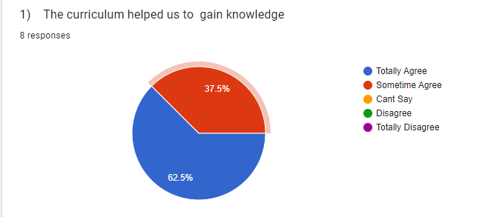
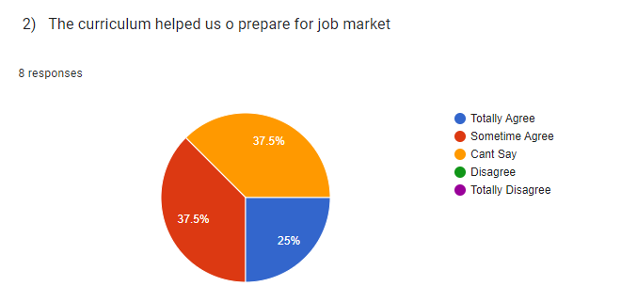
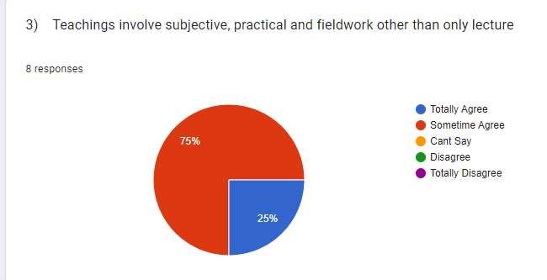

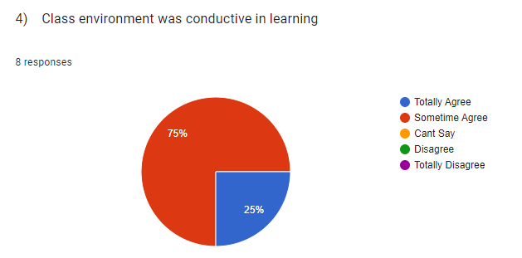
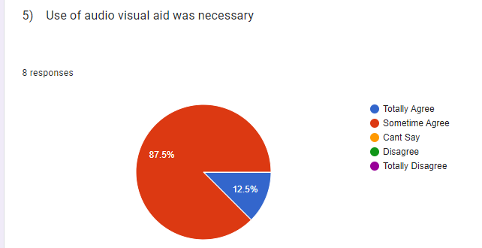
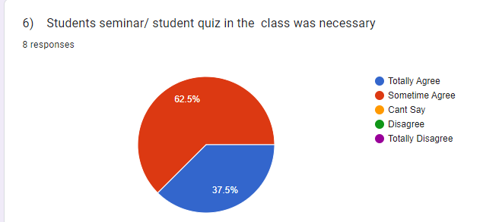
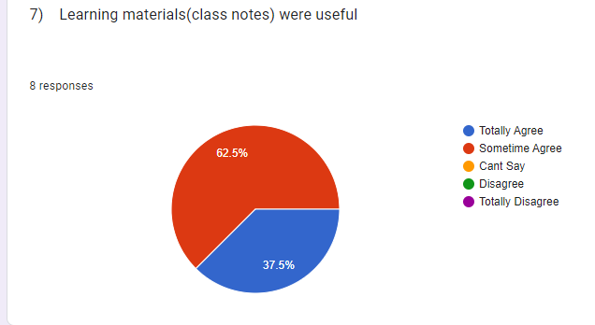

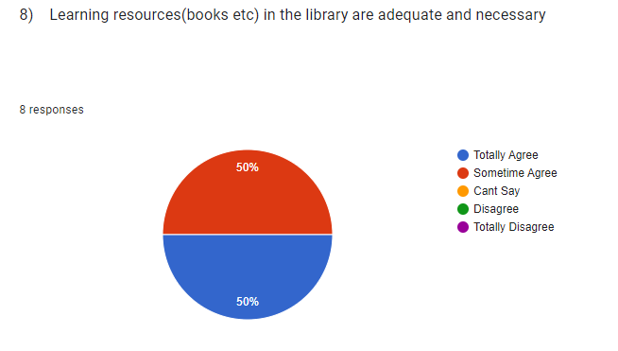
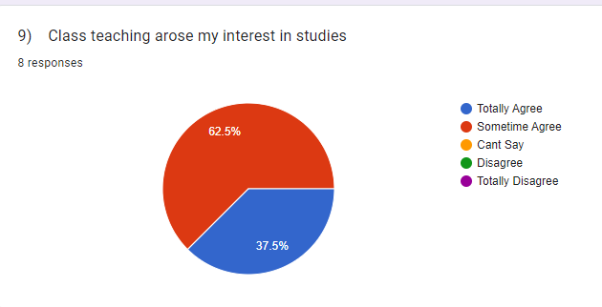
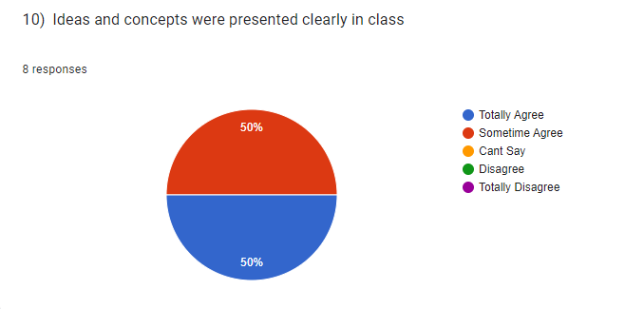

Analysis of the statement’s of Students
S1: Here 62.5% students totally agree responses with the statement, 37.5% sometime agree responses with the statement, 0% can’t say responses with the statement, 0% disagree responses with the statement and 0% totally disagree with the statement.
So, it is the clear from the responses of the student that a majority of the student think that the curriculum helped them to gain knowledge.
S2: Here 25% students totally agree responses with the statement, 37.5% sometime agree responses with the statement, 37.5% can’t say responses with the statement, 0% disagree responses with the statement and 0% totally disagree with the statement.
So, it is the clear from the responses of the students that many students think that the curriculum helped them to prepare for the job market.
S3: Here 25% students totally agree responses with the statement, 75% sometime agree responses with the statement, 0% can’t say responses with the statement, 0% disagree responses with the statement and 0% totally disagree with the statement.
So, it is the clear from the responses of the students that many students think that teachings involve subjective, practical and fieldwork other than only lecture.
S4: Here 25% students totally agree responses with the statement, 75% sometime agree responses with the statement, 0% can’t say responses with the statement, 0% disagree responses with the statement and 0% totally disagree with the statement.
So, it is the clear from the responses of the students that many students think that class environment was conductive in learning.
S5 Here 12.5% students totally agree responses with the statement, 87.5% sometime agree responses with the statement, 0% can’t say responses with the statement, 0% disagree responses with the statement and 0% totally disagree with the statement.
So, it is the clear from the responses of students that a majority of the students think that use of audio visual aid was necessary.
S6: Here 37.5% students totally agree responses with the statement, 62.5% sometime agree responses with the statement, 0% can’t say responses with the statement, 0% disagree responses with the statement and 0% totally disagree with the statement.
So, it is the clear from the responses of the students that many students think that students seminar/ students quiz in the class was necessary.
S7: Here 37.5% students totally agree responses with the statement, 62.5% sometime agree responses with the statement, 0% can’t say responses with the statement, 0% disagree responses with the statement and 0% totally disagree with the statement.
So, it is the clear from the responses of the students that a majority of the students think that learning materials (class notes) were useful.
S8: Here 50% students totally agree responses with the statement, 50% sometime agree responses with the statement, 0% can’t say responses with the statement, 0% disagree responses with the statement and 0% totally disagree with the statement.
So, it is the clear from the responses of the students that a majority of the student think that learning resources (books etc) in the library are adequate and necessary.
S9: Here 37.5% students totally agree responses with the statement, 62.5% sometime agree responses with the statement, 0% can’t say responses with the statement, 0% disagree responses with the statement and 0% totally disagree with the statement.
So, it is the clear from the responses of the students that many students think that Class teaching arose my interest in studies.
S10: Here 50% students totally agree responses with the statement, 50% sometime agree responses with the statement, 0% can’t say responses with the statement, 0% disagree responses with the statement and 0% totally disagree with the statement.
So, it is the clear from the responses of the student that a majority of the student think that Ideas and concepts were presented clearly in class.

GOBINDA PRASAD MAHAVIDYALAYA
SESSION: 2021-2022
DEPARTMENT OF MATHEMATICS
ANALYSIS OF ONLINE STUDENT FEEDBACK ON THE EXISTING CURRICULUM
NAME OF THE TEACHER: DR. SATHI MUKHERJEE

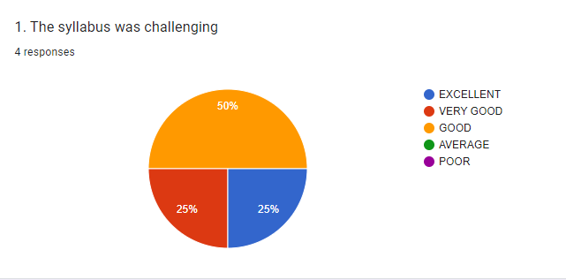

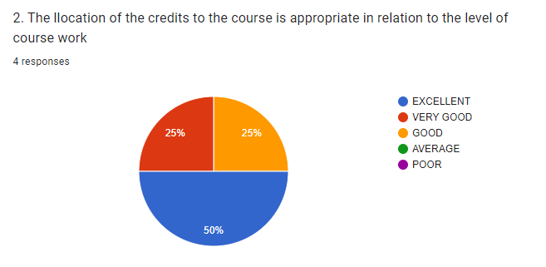

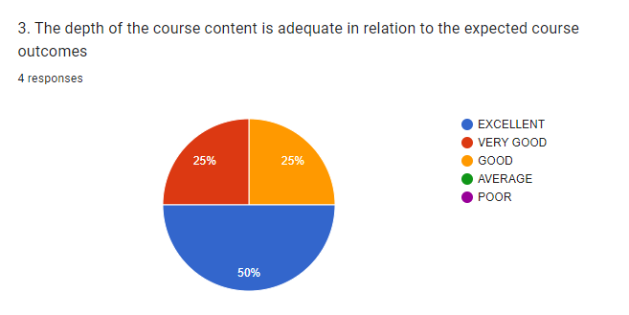

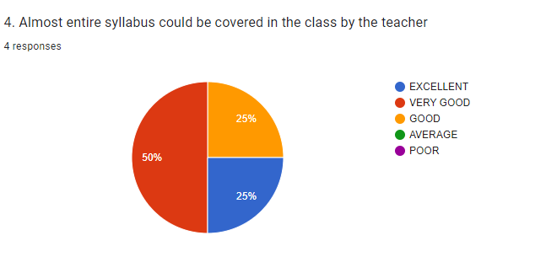

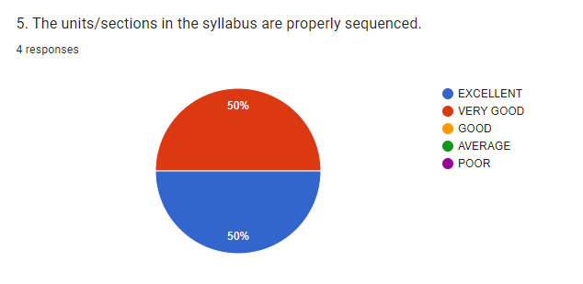

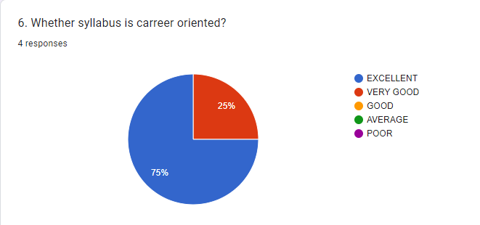

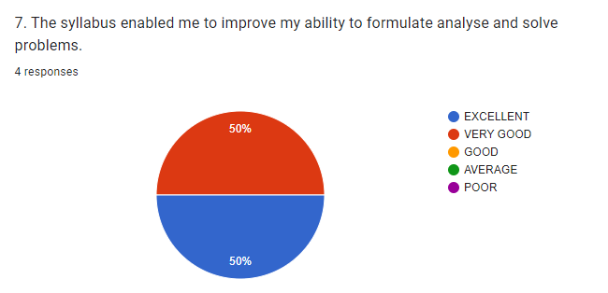

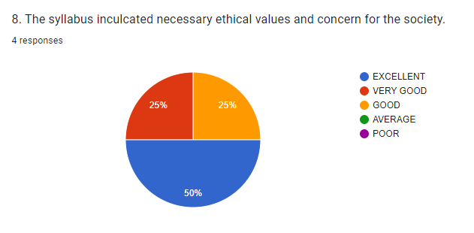

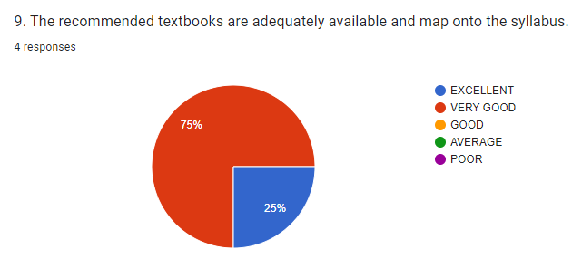

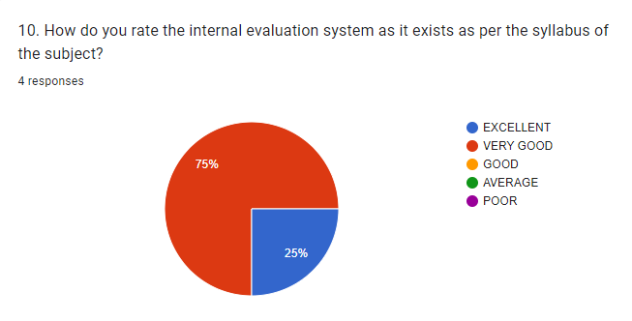

- % of online feedback taken from 04 students
SL  NO | Statements | Excellent | Very Good | Good | Average | Poor
1. | The Syllabus Was challenging | 25 | 25 | 50 | 0 | 0
2. | The allocation of the credits to the course is appropriate in relation to the level of course work. | 50 | 25 | 25 | 0 | 0
3. | The depth of the course content is adequate in relation to the expected Course Outcome | 50 | 25 | 25 | 0 | 0
4. | Almost entire syllabus was covered in the class by the teacher. | 25 | 50 | 25 | 0 | 0
5. | The units/sections in the syllabus are properly sequenced | 50 | 50 | 0 | 0 | 0
6. | Whether syllabus is carrier oriented? | 75 | 25 | 0 | 0 | 0
7. | The syllabus enabled me to improve my ability to formulate, analyse and solve problems. | 50 | 50 | 0 | 0 | 0
8. | Syllabus inculcated necessary ethical values and concern for the society. | 50 | 25 | 25 | 0 | 0
9. | The recommended textbooks are adequately available and map onto the syllabus. | 25 | 75 | 0 | 0 | 0
10. | How do you rate the internal evaluation system as it exists regarding syllabus is? | 25 | 75 | 0 | 0 | 0

Compare of Students Feedback
Analysis of the statements of Students
S1: Here 25% students excellent responses with the statement, 25% very good responses with the statement, 50% good responses with the statement, 0% average responses with the statement and 0% poor responses with the statement.
So, it is the clear from the responses of the student that a majority of the student think that the curriculum helped them to gain knowledge.
S2: Here 50% students excellent responses with the statement, 25% very good responses with the statement, 25% good responses with the statement, 0% average responses with the statement and 0% poor responses with the statement.
So, it is the clear from the responses of the students that many students think that the curriculum helped them to prepare for the job market.
S3: Here 50% students excellent responses with the statement, 25% very good responses with the statement, 25% good responses with the statement, 0% average responses with the statement and 0% poor responses with the statement.

So, it is the clear from the responses of the students that many students think that teachings involve subjective, practical and fieldwork other than only lecture.
S4: Here 25% students excellent responses with the statement, 50% very good responses with the statement, 25% good responses with the statement, 0% average responses with the statement and 0% poor responses with the statement.
So, it is the clear from the responses of the students that many students think that class environment was conductive in learning.
S5 Here 50 % students excellent responses with the statement, 50 % very good responses with the statement, 0 % good responses with the statement, 0 % average responses with the statement and 0% poor responses with the statement.
So, it is the clear from the responses of students that a majority of the students think that use of audio visual aid was necessary.
S6: Here 75% students excellent responses with the statement, 25 % very good responses with the statement, 0 % good responses with the statement, 0 % average responses with the statement and 0% poor responses with the statement.
So, it is the clear from the responses of the students that many students think that students seminar/ students quiz in the class was necessary.
S7: Here 50 % students excellent responses with the statement, 50 % very good responses with the statement, 0 % good responses with the statement, 0% average responses with the statement and 0% poor responses with the statement.
So, it is the clear from the responses of the students that a majority of the students think that learning materials (class notes) were useful.
S8: Here 50 % students excellent responses with the statement, 25 % very good responses with the statement, 25 % good responses with the statement, 0% average responses with the statement and 0% poor responses with the statement.
So, it is the clear from the responses of the students that a majority of the student think that learning resources (books etc.) in the library are adequate and necessary.
S9: Here 25 % students excellent responses with the statement, 75 % very good responses with the statement, 0 % good responses with the statement, 0 % average responses with the statement and 0 % poor responses with the statement.
So, it is the clear from the responses of the students that many students think that Class teaching also my interest in studies.
S10: Here 25 % students excellent responses with the statement, 75 % very good responses with the statement, 0 % good responses with the statement, 0% average responses with the statement and 0% poor responses with the statement.
So, it is the clear from the responses of the student that a majority of the student think that Ideas and concepts were presented clearly in class.

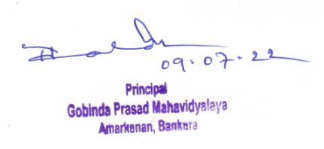

Dr. Tushar Kanti Halder
Principal
Gobinda Prasad MAhavidyalaya

